**generic software process models**

**-the waterfall model**

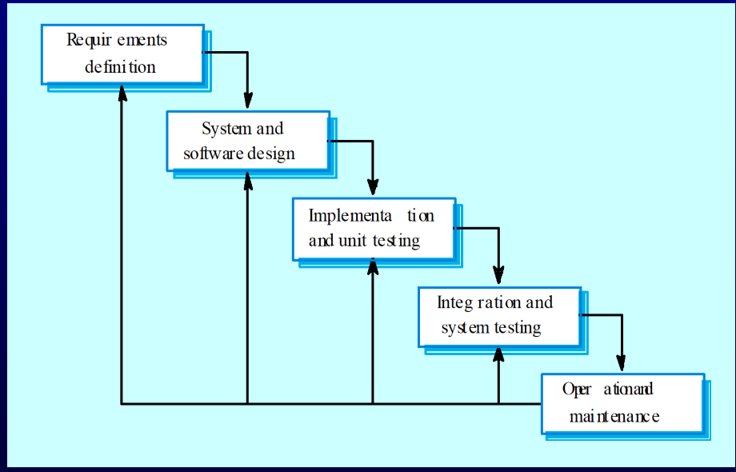

-难以根据需求改变

**-evolutionary development**

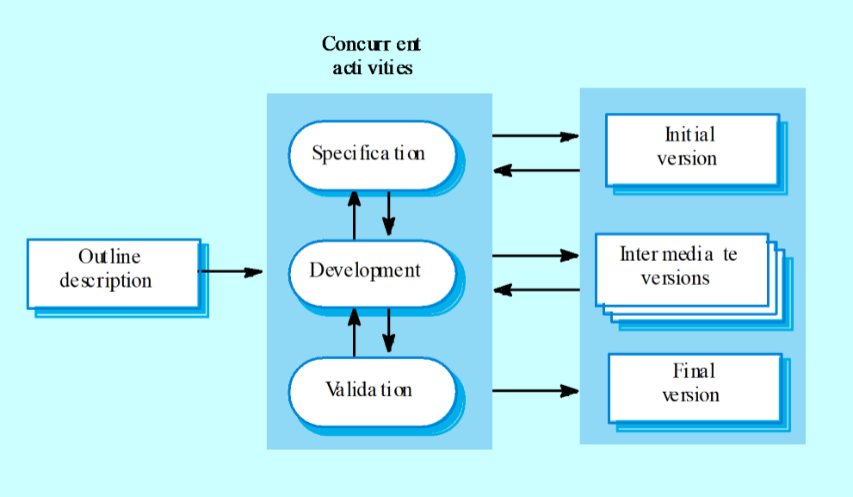

Problems

• Lack of process visibility;

• Systems are often poorly structured;

• Special skills (e.g. in languages for rapid prototyping) may be required.

Applicability

• For small or medium-size interactive systems;

• For parts of large systems (e.g. the user interface);

• For short-lifetime systems.

**-component-based software engineering**

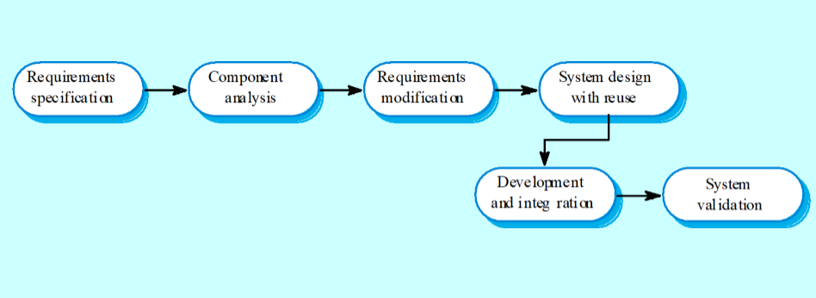

**Process iteration**

- System requirements ALWAYS evolve in the course of a project so process iteration where earlier stages are reworked is always part of the process for large systems.

- Iteration can be applied to any of the generic process models.

- Two (related) approaches

• Incremental delivery;

• Spiral development.

**Incremental development**

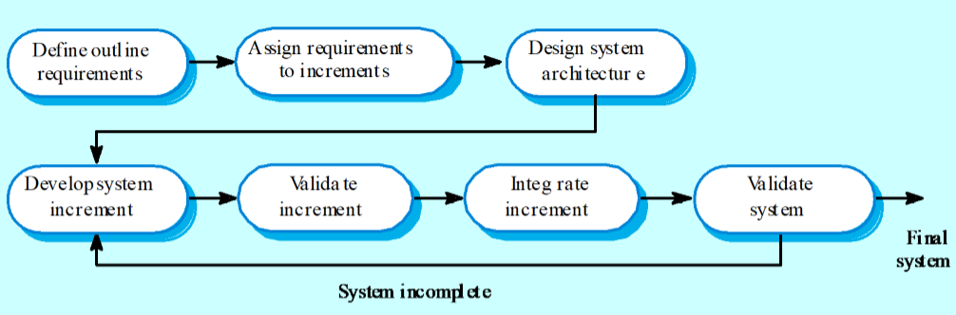

- Customer value can be delivered with each increment so system functionality is available earlier.

- Early increments act as a prototype to help elicit requirements for later increments.

- Lower risk of overall project failure.

- The highest priority system services tend to receive the most testing.

**Spiral development**

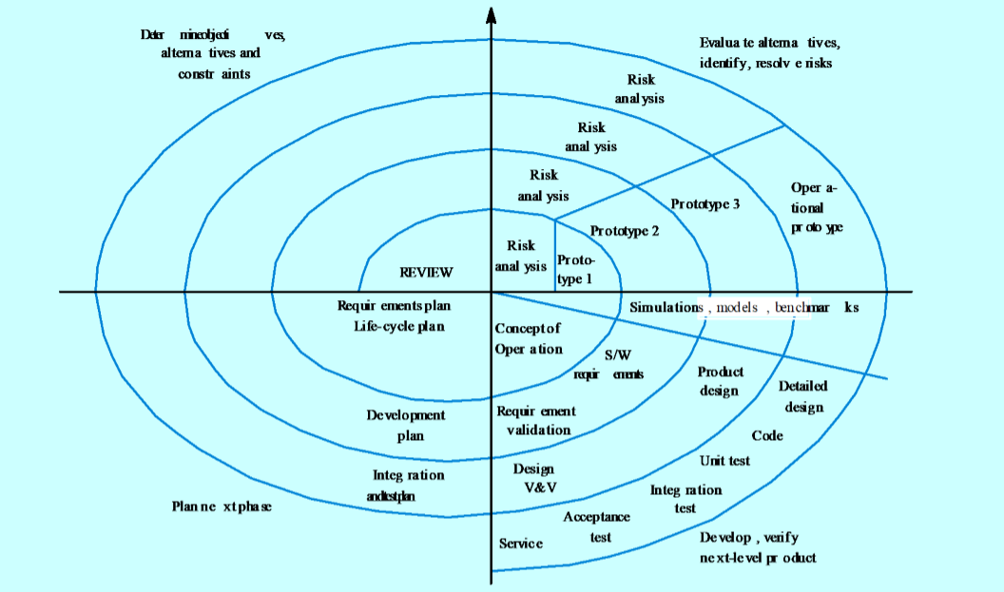

• Specific objectives for the phase are identified.

• Risks are assessed and activities put in place to reduce the key risks.

• A development model for the system is chosen which can be any of the generic models.

• The project is reviewed and the next phase of the spiral is planned.